Agenda

*Date: 02/15/14*

*Location: Brody Collaborative Space - Room 1045 and 1042*

*Actual Time: 1 pm - sometime*

*Planned Length: a while*

***Silly Picture of the Week:***

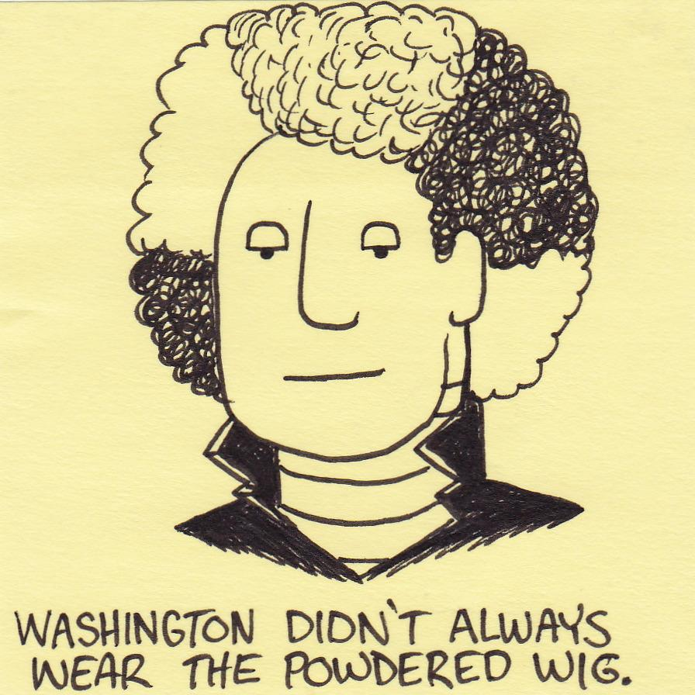

***Please add and comment on anything and everything in the agenda!***

|  |  |  |  |
| --- | --- | --- | --- |
| **Team Member(s)** | **Topic** | **Time** | **Goals** |
| Anyone | Announcements | 5 min | If any new developments have occurred the team is updated on them |
| Everyone! | Pay Shannon $6.21 | Rolando, JT, John, Mark, Arvind, Si, Brian, Andrew, Brian, David, Xiameng, shumin | Total was $157  TIES reimbursement was $5 * 14 = $70  = $6.21  **Pay Shannon $6.21** |
| ~~Shannon + Hardware~~ | ~~Design Changes?~~ | ~~10 min~~ | ~~Discuss eye theory and possible changes/additions to the bracket design~~ |
| Shannon | Modify code to measure in mm |  | User can input distance (or it will be a fixed constant) and mm can be measured. Test with hardware pictures and a ruler. |
| David and Brian | Strabismus | 30 min | Test strabismus code |
| Shumin | Test with red eye photos | If there is time | Get red eye photos from the hardware team; Develop documentation to begin quantifying the accuracy of the detections for eye, pupil, white dot, and crescent (so that we can get a % accuracy for each one) |
| Arvind and Andrew | Hardware | a while | Make plan for getting lots of red eye photos ; or work with bracket/camera; or other stuffz |
| Front End | Fix rectangle bug, make more pages |  | Do other cool things |
| Xiaomeng, Brian, and Si | Fix Bugs |  | All bugs found in code from testing are fixed. |
| Shannon | Recap, Next steps and Weekly Deliverables | 10 min. | Meeting progress/ goal accomplishment is recapped. Next steps are outlined so that every team member goes into next week knowing what they are expected to contribute. Weekly deliverables are updated by all team members |

# Notes

* Pushed photos onto github in the homemade folder under Photos

# Summary

# 

After talking with Dr. Bartsch we learned that getting the measurement that the client wants (sphere(diopters), cylinder(diopters), and axis(degrees) -- a prescription) will cause significant design changes.

It works as follows:

To convert refractive error to diopters we will need to a mathematical model of the eye similar to the ones laid out in this paper: <http://www.opticsinfobase.org/view_article.cfm?gotourl=http%3A%2F%2Fwww%2Eopticsinfobase%2Eorg%2FDirectPDFAccess%2F2EAB9F5F-AAE3-1B2A-AA0853CBADC441F8_73354%2Foe-11-14-1628%2Epdf%3Fda%3D1%26id%3D73354%26seq%3D0%26mobile%3Dno&org=>

To find the axis and ensure the accuracy of the sphere and cylinder measurements we will need to take 18 pictures, each with the flash offset ten degrees more than the last. One possible way to do this is to have 18 flashes surrounding the camera in an arc, only one of which goes off per photo. [Photo of PlusOptix showing an example of this](https://78462f86-a-1a477c30-s-sites.googlegroups.com/a/tecnoptix.com/www/estudios-clinicos/plusoptix_s04.jpg?attachauth=ANoY7cqdfMWGdeYfbMoUYaH0hnSDuCCp92r6Nj-o96NmLMxyFepL9HSlGY5zxegX89wX2zi004diE-cP7e_gpPhaAhGtRecXisP8sFd8nFzx6Rgv61GL5FB6PBOFpkJiTfDH5SJce2nqqtTOQ2sLmh43JSk9uKmoMqu6cIdFBP6kuoSAvLc-3pCzUHj3Q9na-5iYxR71BTSNyMpjJxG42pIR5_ut_00e3kPkSXEgOBQKFqL9FmOqOOY%3D&attredirects=0). Once we have these 18 photos and have converted the refractive error to diopters we can make a graph like so:

Note: refractive error is also called power when it is in diopters

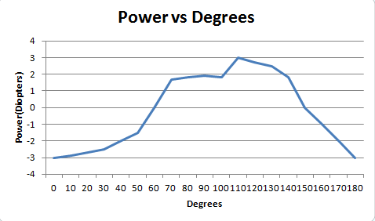

The peak of this curve is the cylinder. Here it is +3. The peak - the min is the sphere. Here it is 0. And the axis is the degrees at which the peak occurs. Here it is 110 degrees.

Obviously, if we choose to get the measurements in this way it will cause design changes in all subteams. I’ve emailed the client about it and we may be meeting her Wednesday.

# Whiteboard Pics

# Useful Links

Front-End Frame Documentation: <http://docs.wxwidgets.org/2.8.11/wx_wxframe.html#wxframe>

Dropbox: <https://www.dropbox.com/sh/8nsmamaiklpvr9l/Fo5xgv4ogH>

<http://scrumy.com/DVSWinter2014>

Front-End Code for User Drawing <https://groups.google.com/forum/#!topic/wxpython-users/cDqEj_pTnjs>

Spherical Equivalent Documentation

<http://www.nfos.org/degree/opt11/module_09b.html>

Study about converting mm of crescent area/pupil area to diopters: http://www.opticsinfobase.org/view_article.cfm?gotourl=http%3A%2F%2Fwww%2Eopticsinfobase%2Eorg%2FDirectPDFAccess%2FC7517C18-BBC5-8CE2-AD9E51693E5BE534_73354%2Foe-11-14-1628%2Epdf%3Fda%3D1%26id%3D73354%26seq%3D0%26mobile%3Dno&org=

sphere, cylinder, axis:

<http://www.allaboutvision.com/eyeglasses/eyeglass-prescription.htm>